Factiva

Go to <https://researchguides.library.brocku.ca/az.php?a=f>

Find factiva, click and login with your Brock account.

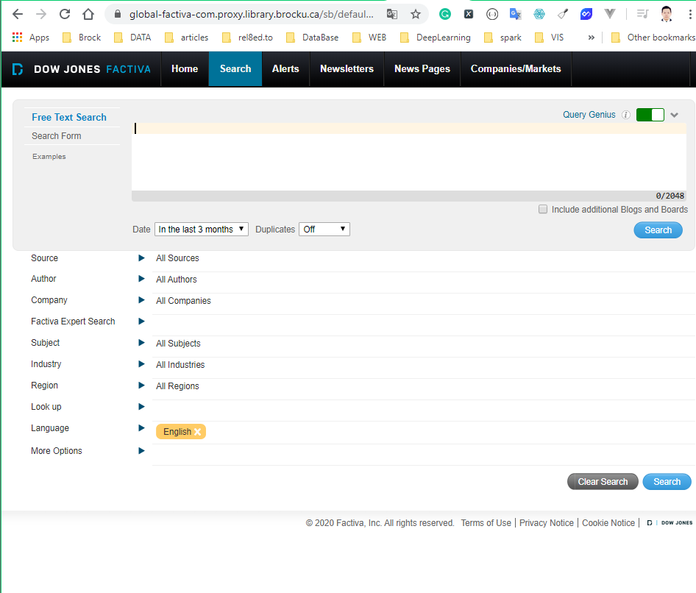

Input the time range

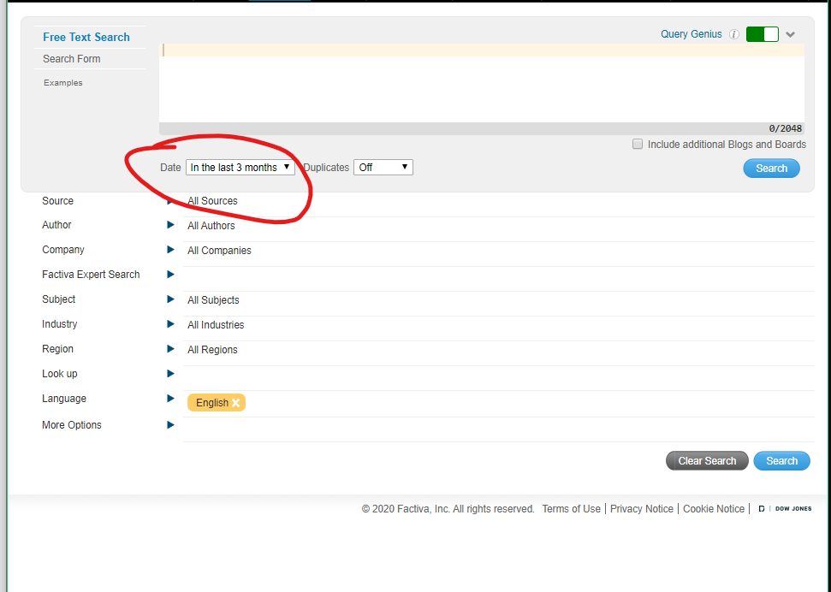

Set time from 2000-01-01 to 2019-12-31, and choose “Similar” for Duplicates

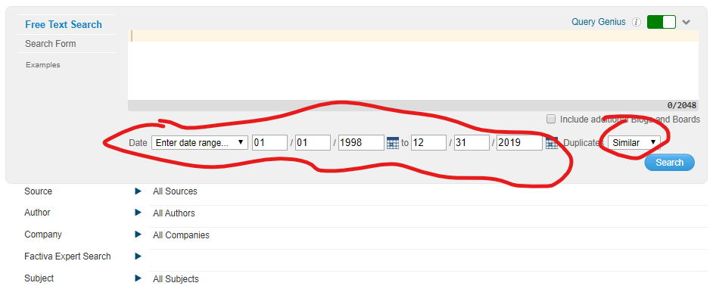

Choose United States for region

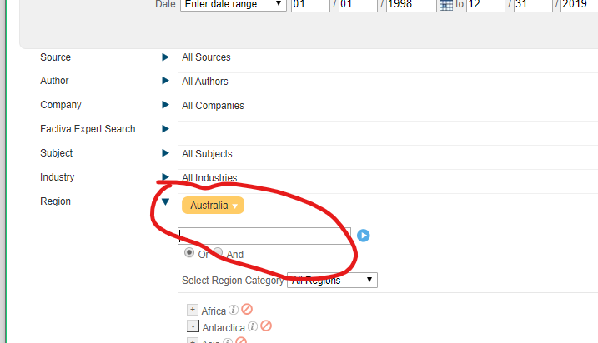

Choose the source as the target publication, better one by one

List:

USA Today - All sources

The Wall Street Journal - All sources

The New York Times - All sources

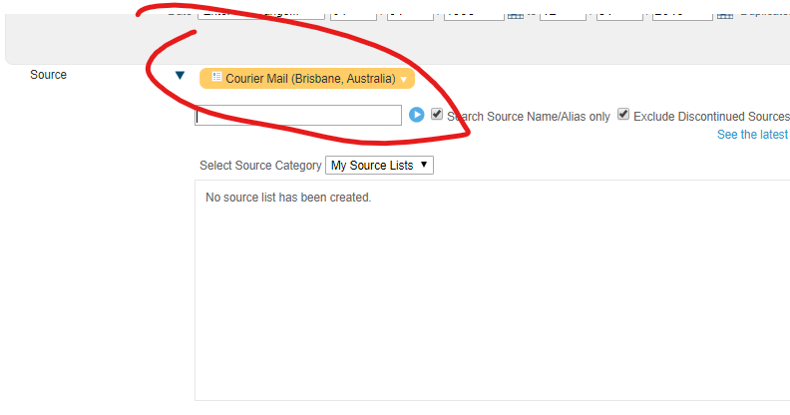

Set the subject with

“Real Estate Markets”, “Housing Starts” and “Home Sales/Housing Affordability Figures” with the relation of “OR”

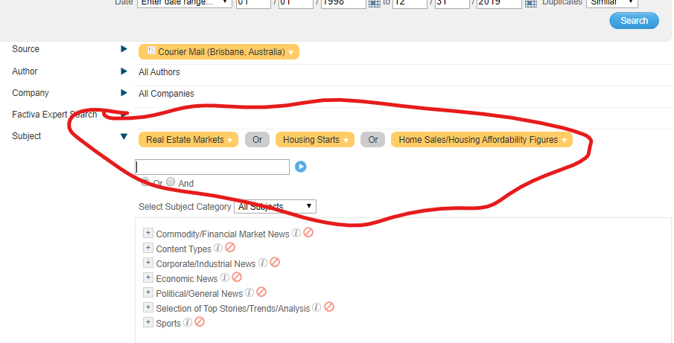

Download the first page:

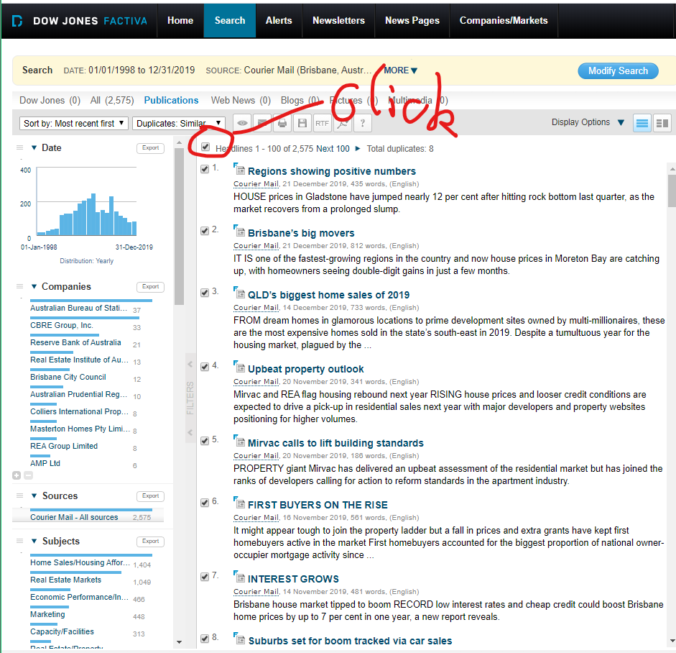

Find the “Save” icon, click and choose “ Article Format”

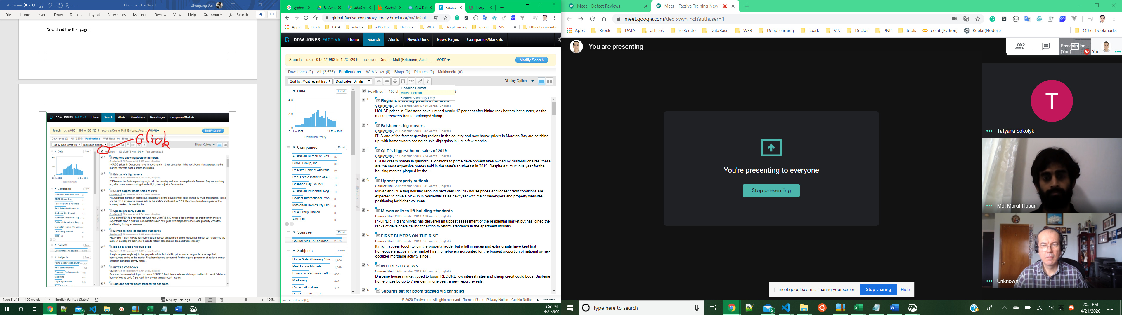



Save as into a folder named by the source, for example:” Courier Mail”. Name the file as source + order like “CourierMail1.html” (No space or special punctuations in the file name)

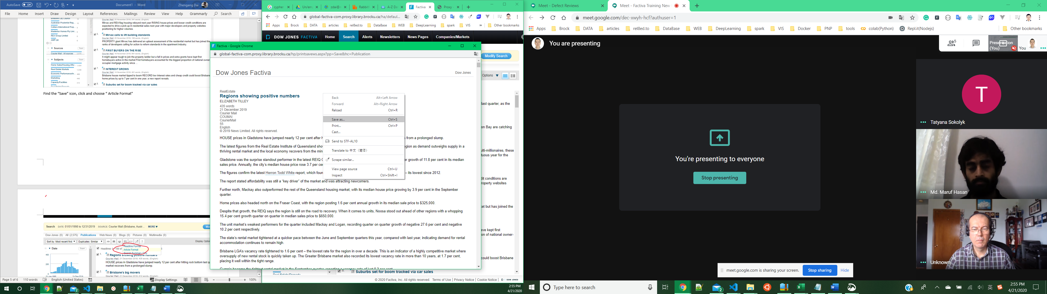

Unselect “select all”,

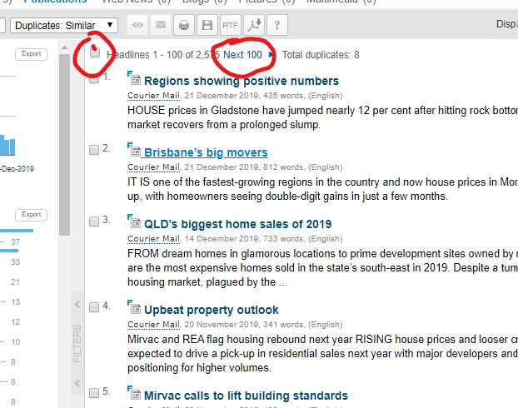

Go to the next page:

Repeat the downloading process.

Upload the folder to Gdrive shared folder>United States>Factiva

